Sri Lanka Institute of Information Technology

User Experience Engineering – SE3050

Lab Sheet 03



GROUP ID: **2021S1_REG_WD_05**

|  |  |
| --- | --- |
| **Registration Number** | **Name** |
| IT19153414 | Akeel M.N.M |
| IT19175126 | Zumry A.M |
| IT19167442 | Nusky M.A.M |

**Persona(s)**

IT19153414 – Akeel M.N.M

Persona – Business Owner

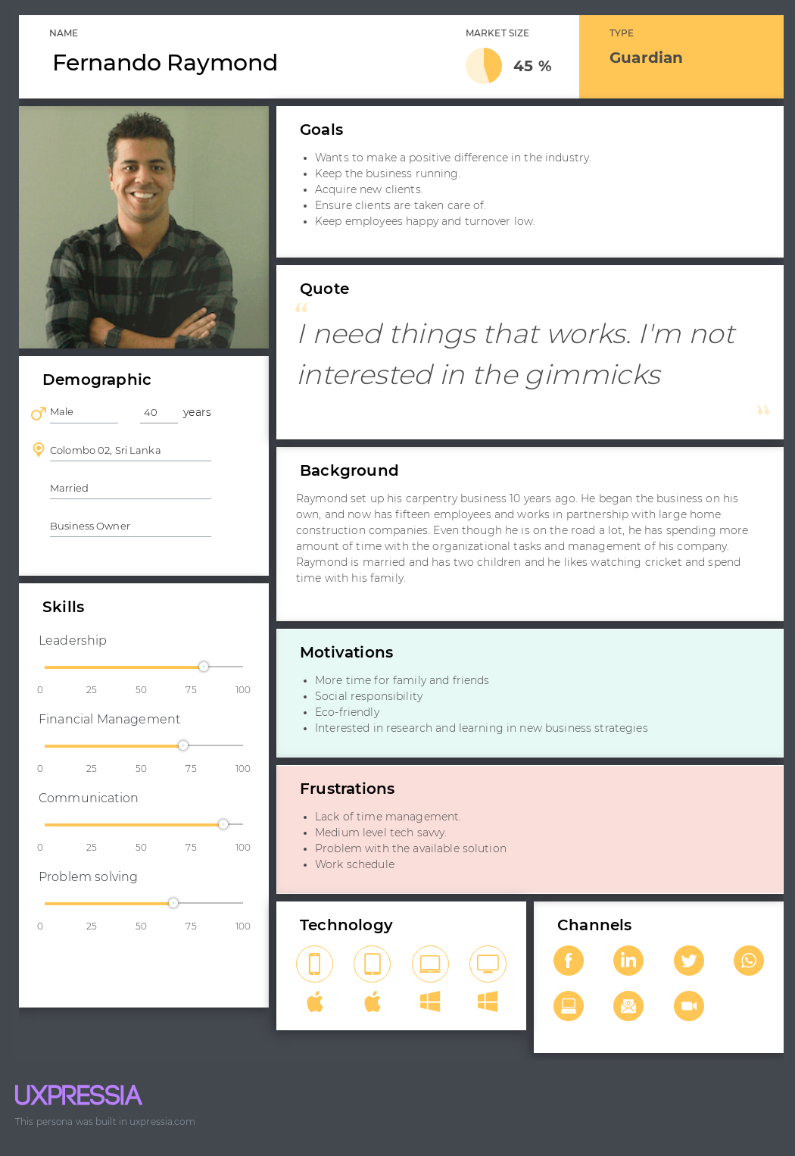

IT19167442– Nusky M.A.M

Persona– PM Manager

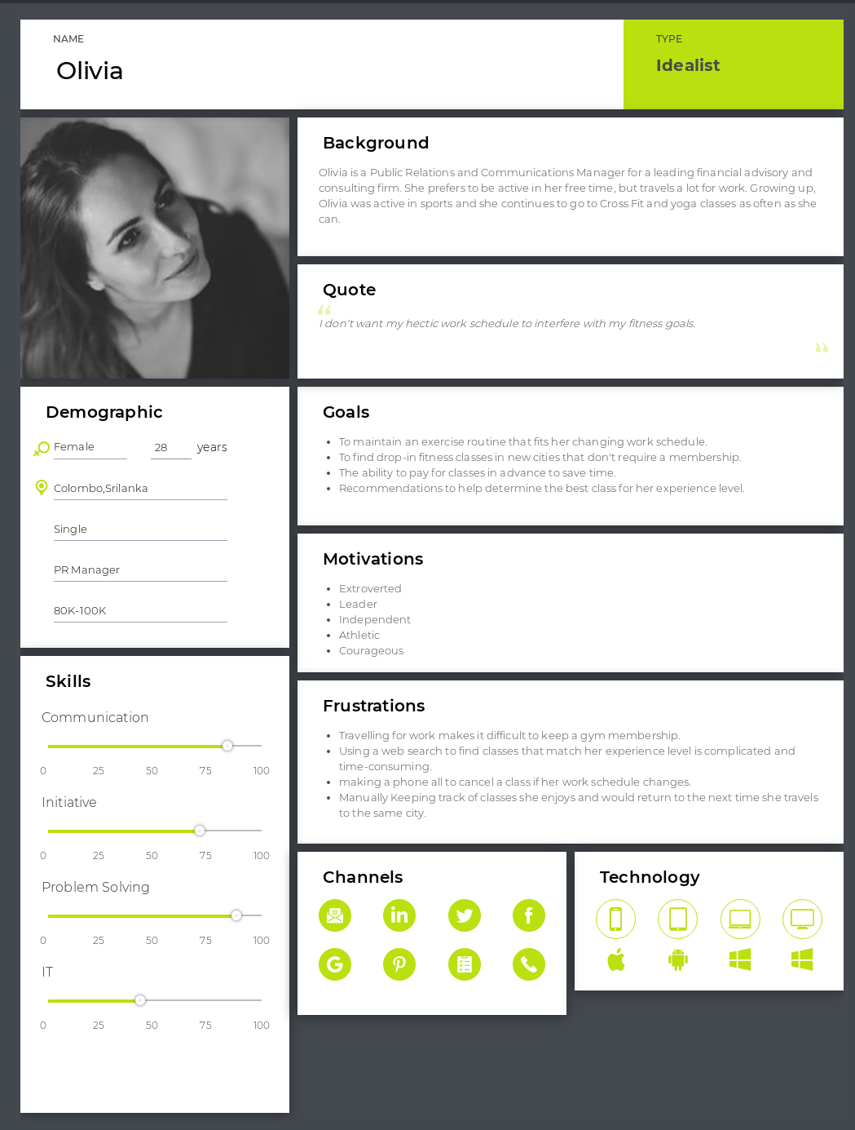

IT19175126 – Zumry A.M

Persona – Shop Owner

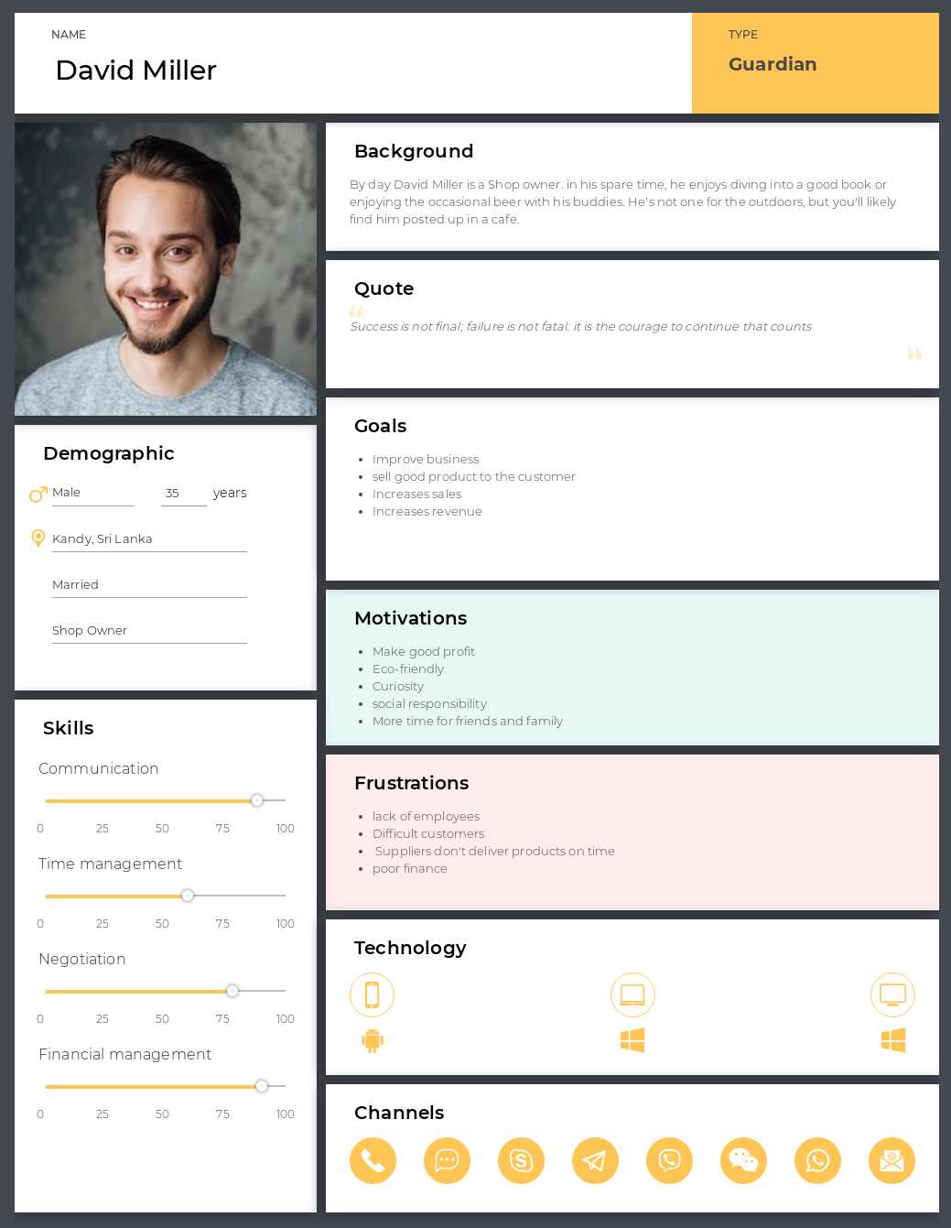

**Empathy Map(s)**

IT19153414 – Akeel M.N.M

Empathy Map - Make Bill Payment

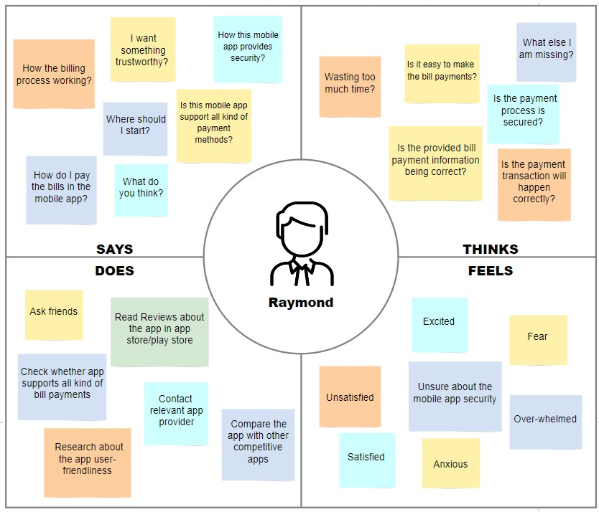

IT19167442– Nusky M.A.M

Empathy Map – Login/Register and Raise Complaint

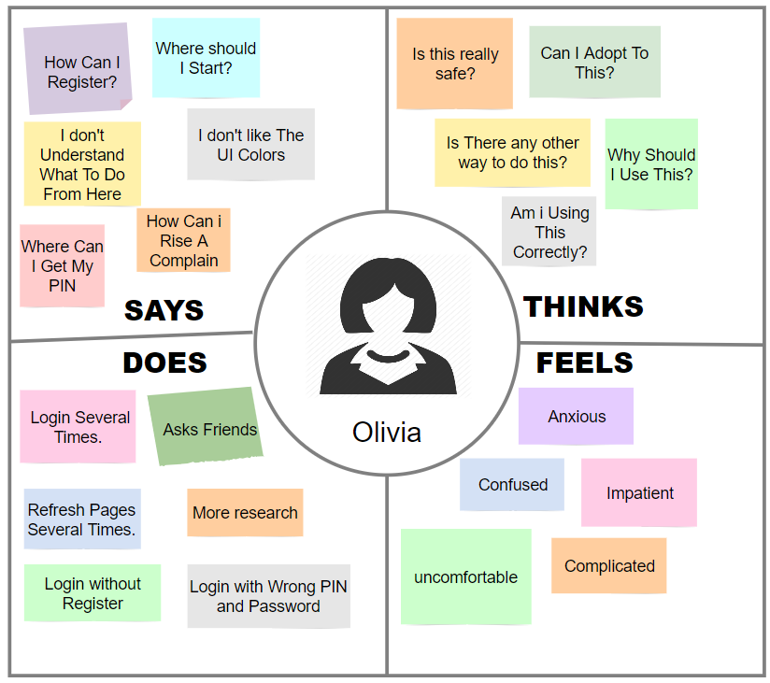

IT19175126– Zumry A.M

Empathy Map – Online transaction

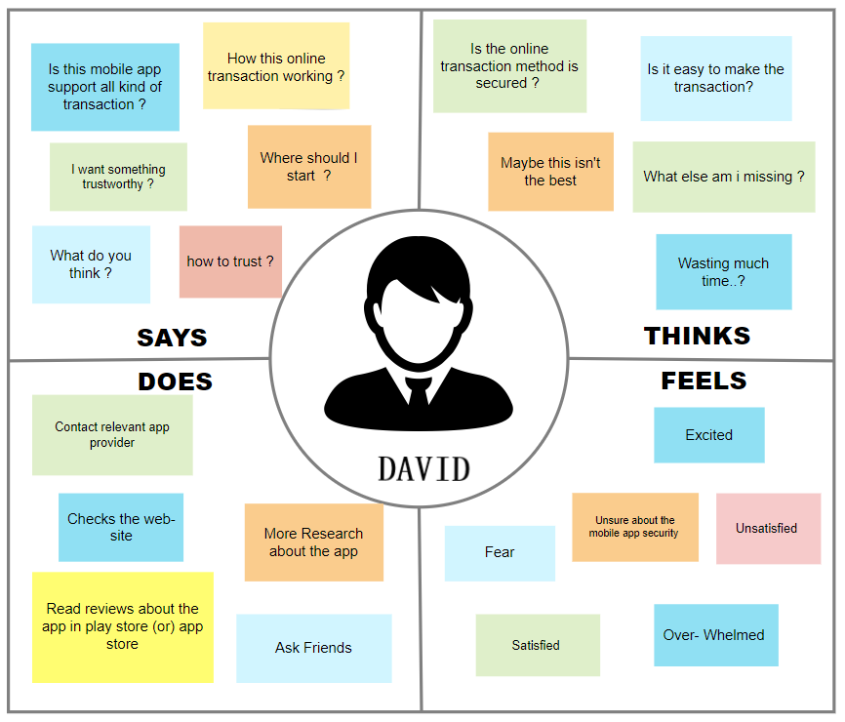

**User Stories**

IT19153414 – Akeel M.N.M

User Story – Make Bill Payment

As a Business Owner

I want to pay my home utility bills online

So that I can save time spending on physical payment methods

IT19167442– Nusky M.A.M

User Story – Raise Complaint

As a PR Manager

I want to raise complaints about disputed transactions using the app

So that it will be notified to the merchant instantly.

IT19175126 – Zumry A.M

User Story – Make Transaction

As a Shop owner

I want to transfer money to the product supplier in online

So that I can easily manage my payments.

**User Flow(s)**

IT19153414 – Akeel M.N.M

User Flow – Make Bill Payment

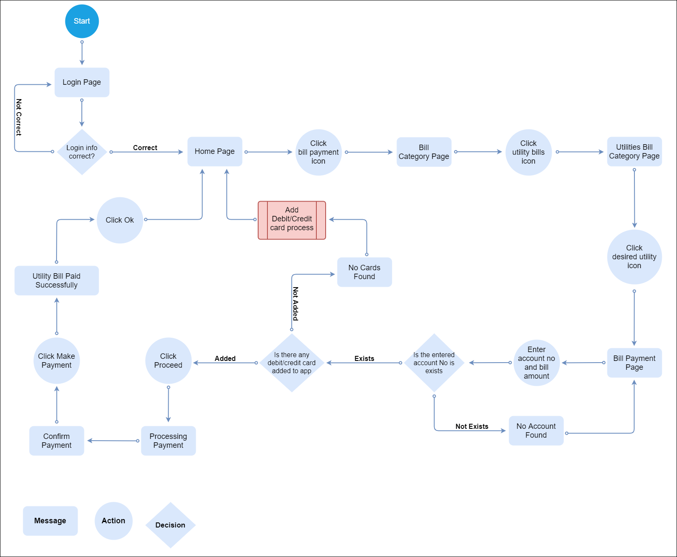

IT19167442– Nusky M.A.M

User Flow – Login/Register and Change Password

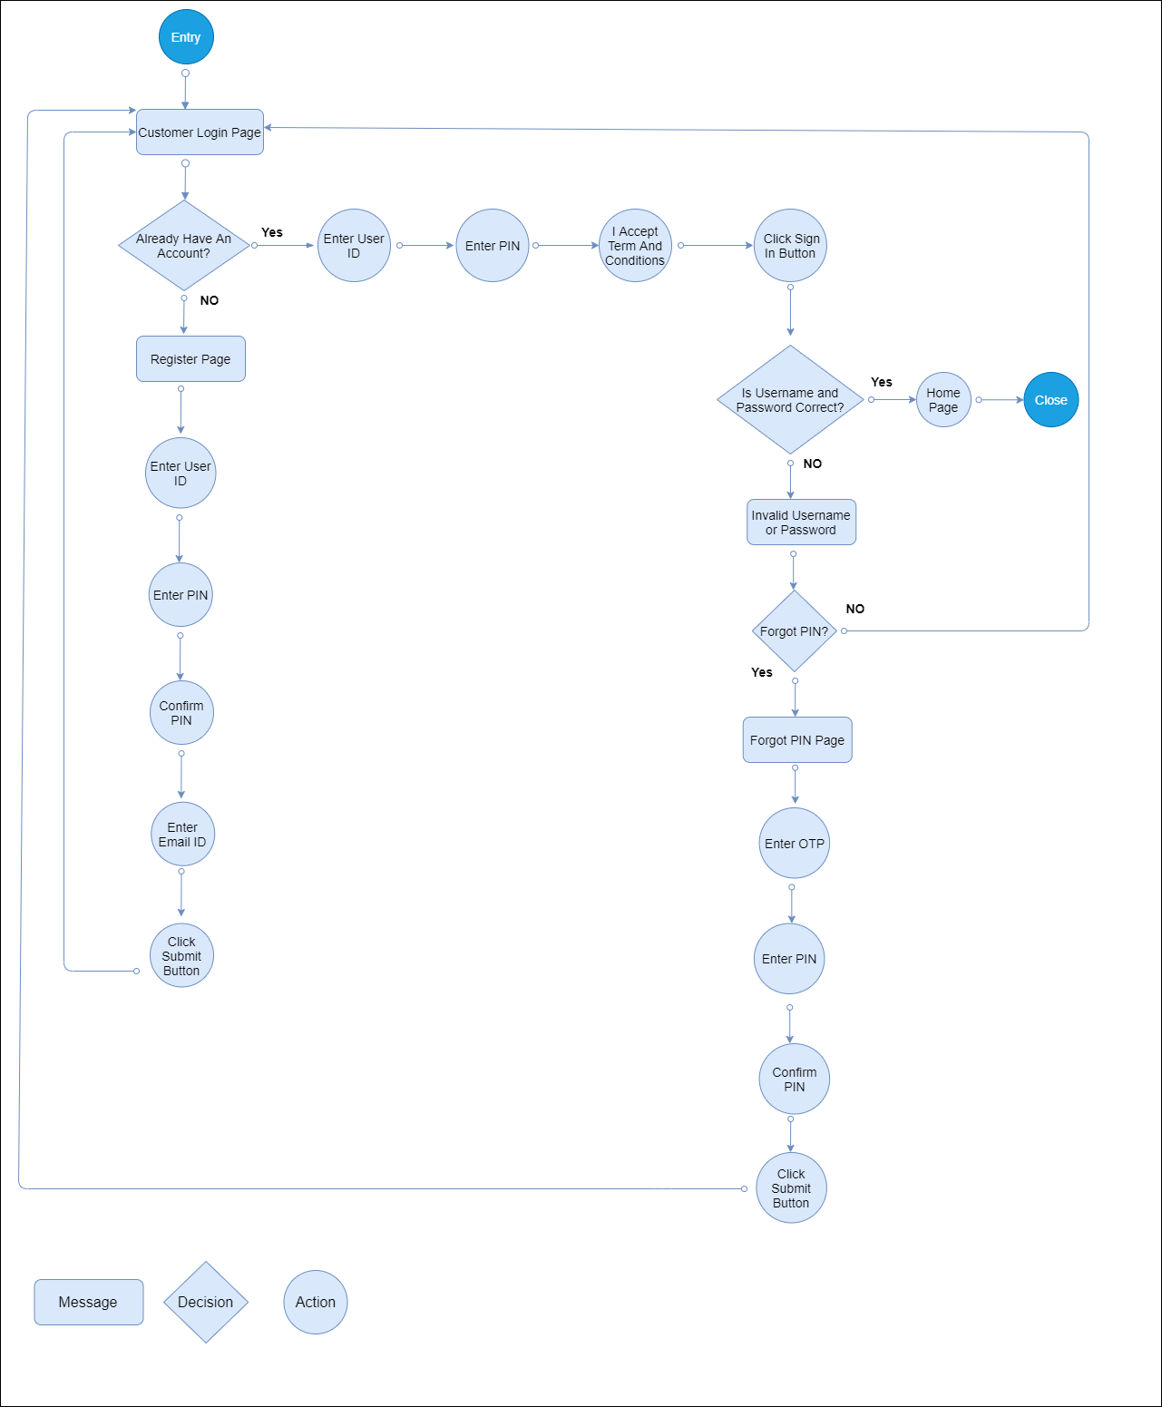

IT19175126 – Zumry A.M

User Flow – Make Transaction

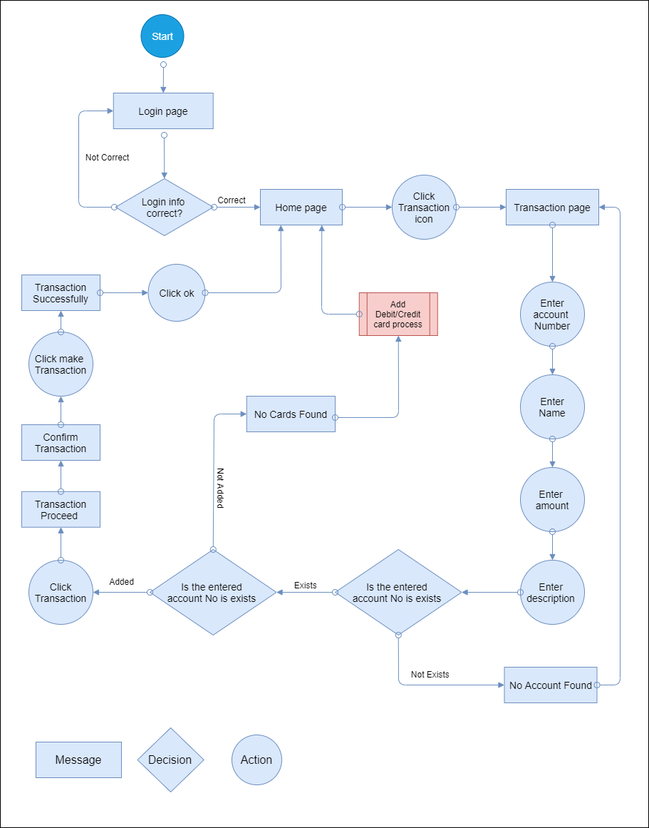

**Service Blueprint**

